**Black Glass Pots Storage Floating Wall Shelf**

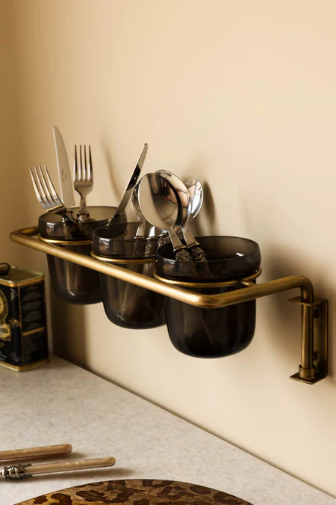 The Black Glass Pots Storage Floating Wall Shelf is a sleek and contemporary addition to any home. Combining a minimalist black frame with durable glass shelving, this unit is perfect for organizing and displaying potted plants, decorative items, or small essentials. The transparency of the glass adds an airy, open feel, while the black finish provides a modern and bold contrast. Ideal for living rooms, kitchens, or bathrooms, this versatile shelf enhances functionality and style, seamlessly blending into modern or industrial-inspired interiors.